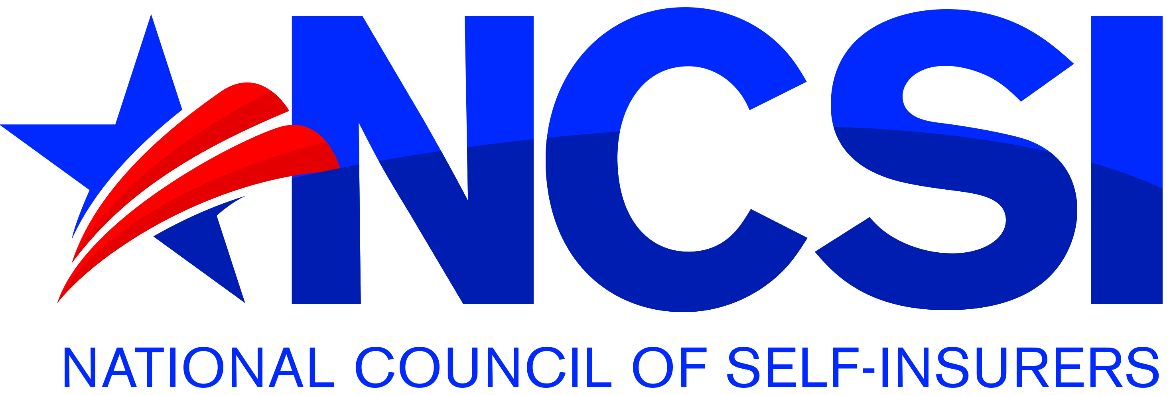 NCSI Conference Speaker Application & Guidelines
The National Council of Self Insurers has supported the interests of workers’ compensation self-insurers since 1946. We welcome speakers in a wide variety of topics that are geared towards the specific needs of our members. Requests to present at the NCSI Annual Meeting will be reviewed by the NCSI Program Committee. Sessions may be limited to 50 minutes for individual speakers and 90 minutes for panel presentations but depending on the topic those timeframes may be amended.
All proposed speakers must submit a bio including prior speaking engagements along with this Application.
Selection Criteria
Proposals will be selected based on the following:
- Topic is innovative, current, cutting edge, engaging and relevant to self-insurers, claims administrators, adjusters, and attorneys in the management of workers’ compensation claims
- Proposal contains specific “take-aways” for the audience that will improve risk management, safety, claims handling and performance
- Speaker(s) is/are passionate about the topic
- Topics are eligible for continuing education credits for adjusters and attorneys
- Preference may be given to speakers who are members of NCSI
Speakers must conform to the following guidelines:
- Refrain from any direct marketing of a product or service during the presentation and in the presentation slides
- Provide content by the print deadlines, which will be provided upon selection of the topic
- Presented using only the NCSI Template
Application
Name
Title
Company
Email
Phone

Presentation Title:

Presentation Type: Panel Individual
If you are planning to present with others, please provide their name, title, company, email, and phone contact. Add additional pages if necessary.
Name
Title
Company
Email
Phone
Presentation Topic and Goal(s): (include what you believe to be the main “take-aways” from the program)

Please provide a biographical summary of your experience with this proposed topic. What is it that makes you (and other panel members, if applicable) a compelling speaker for this topic?

Email this application to Jill Dulich, NCSI Interim Executive Director: jill.dulich@natcouncil.com
2019 NCSI Annual Meeting Application Deadline: March 1, 2019

Thank you for your interest in serving NCSI members

