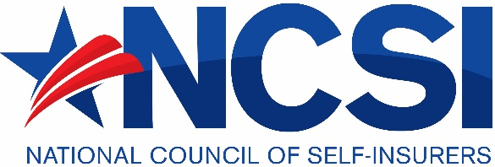
NCSI 2021 Annual Meeting
Conference Speaker Application & Guidelines
The National Council of Self-Insurers’ has supported the interests of workers’ compensation self-insurers since 1946. We welcome speakers in a wide variety of topics that are geared towards the specific needs of our members. The theme for our 2020 conference is: How to build a better Self-Insurance Program.
Do you have an idea for a great presentation or have a subject matter that you would like covered that fits with our theme? If so, submit your proposals here!
Selection Criteria:
- All presentations must focus on ways for self-insured employers to improve the governance or management of their workers’ compensation programs. We are specifically looking for topics that have the “how to . . .” as the main take-away.
- All panels must include a self-insured employer representative.
- Individual presentations will be assigned an NCSI Board of Managers member to moderate the session.
- Topics should be innovative, current, engaging and relevant to self-insured employers, claims administrators, adjusters, and attorneys in the management of workers’ compensation claims.
- Speaker(s) must be industry experts on the topic and passionate about the subject.
- Topics must be eligible for continuing education credits for adjusters and attorneys.
- Preference will be given to speakers who are members of NCSI.
Speakers must conform to the following guidelines:
- Refrain from any direct marketing of a product or service during the presentation and in the presentation slides
- Provide content by the print deadlines, which will be provided upon selection of the topic
- Presented using the NCSI Template

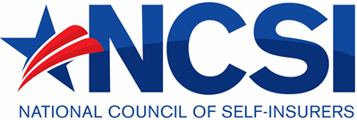
APPLICATION
Name
Title
Company
Email
Phone

Presentation Title:

Presentation Type: Panel Individual

If you are planning to present with others, please provide their name, title, company, email, and phone contact. Add additional pages if necessary.
Name
Title
Company
Email
Phone

Presentation Topic and Goal(s): (include what you believe to be the main “take-aways” from the program)

Please provide a biographical summary of your experience with this proposed topic. What is it that makes you (and other panel members, if applicable) a compelling speaker for this topic?

Email this application to Jill Dulich, NCSI Executive Director: jill.dulich@natcouncil.com
NCSI Annual Meeting Conference Application Deadline: January 15, 2020.
Email this application to Jill Dulich, NCSI Program Committee Chair jilldulich@securityfund.org
NCSI Annual Meeting Conference Application Deadline: April 10, 2021
Thank you for your interest in serving NCSI members!

